Invitation to Quote (ITQ): AccountanCity 2027
- Introduction
AccountanCity is ISCA’s career exploration event targeted towards youths, young professionals and mid-career professionals to showcase exciting career pathways and opportunities in the accountancy sector.
Key partners in the past include the Employment and Employability Institute (e2i), Accountancy and Auditing firms, corporates and Institutes of Higher Learning.
AccountanCity has been running since 2023 and has been held at ISCA House with 1,000 pax across 2 days. To find out what was done in 2026, please visit the link https://accountancity.sg/ and check out our 2026 LinkedIn posts.
2026 Day 1 - https://www.linkedin.com/posts/institute-of-singapore-chartered-accountants_what-a-start-to-accountancity-2026-activity-7484089511757676544-00NE/
2026 Day 2 - https://www.linkedin.com/posts/institute-of-singapore-chartered-accountants_thats-a-wrap-on-accountancity-2026-activity-7484237447682367488-95c5/

- Event Overview
Event Name | AccountanCity 2027
Theme | To be proposed under Scope of Work
Suggested Dates | 27 May 2027 (Thu) – Set Up  28 May 2027 (Fri) – Event Day
Event Duration | 10am – 5pm
Expected Attendance | 1,800 pax
Notable Attendees | Students from Institutes of Higher Learning, Young Professionals, Mid-Career Professionals
Venue | ISCA House

- Key Information
ITQ Deadline: 28 September 2026 (Monday), 6pm
Point of Contact:
Name | Designation | Email
Jia Yin CHUA (Ms) | Events Lead | jiayin.chua@isca.org.sg

Submission Mode:
Tenderers shall submit their Tender Offers in accordance with the following mode(s) of submission:
- Proposal
- Quotation
All proposals and quotations must be submitted by 28 September 2026 (Monday), 6pm. Any submission after the indicated deadline will not be considered.
Mode of Submission: Email proposal and quotation to jiayin.chua@isca.org.sg

By submitting a tender, you agree to all our terms and conditions.

- Evaluation Criteria
All proposals that adhere to the terms and conditions of the ITQ will be evaluated based on the following criteria:
Criteria | Weightage
Past Track Records of Similar Events | 10%
Overall Concept, Theme and Ideas to create a unique experience | 30%
Any Value-added services / Unique services that can be provided | 25%
Overall Cost | 35%

ISCA reserves the right to reject any tenderers and is not obligated to share reasons for the rejection.

- Timeline
Date | Activity
7 Sep 2026 (Mon) | ITQ Opens
7 (Mon) – 18 Sep 2026 (Fri) | Open Q&A  (Agencies may write in to seek clarification. Q&As after the deadline will not be entertained.)
28 Sep 2026 (Mon) | ITQ Submission Closes at 6pm
29 Sep (Tue) – 19 Oct (Mon) 2026 | Proposal Review Period
20 (Tue) – 23 Oct 2026 (Fri) | Presentation of Shortlisted Proposals
26 Oct (Mon) – 9 Nov 2026 (Mon) | Management Evaluation
10 (Mon) – 20 Nov 2026 (Fri) | Appointment of EO
28 May 2027 (Fri) | AccountanCity 2027

- Scope of Work
The appointed EO will be responsible for the end-to-end management of the event, including but not limited to:
S/N | Scope of Work
1 | Conceptualisation of event theme
2 | Design and Creation of Key Visual
Adaptation of Key Visual for, but not limited to, the following:
- Event Backdrop
- On site Signages
- Social Media Posts (e.g. Linkedin, Facebook, Instagram)
- Powerpoint Template
3 | Website Design and Management
4 | Event Registration (Onsite Manpower only, ISCA has our own Registration system)
5 | Plan and conceptualise engagement activities for attendees
6 | Conceptualise an overarching activity to get attendees to visit exhibitors
7 | Exhibition Floor Planning & Layout
8 | Exhibition Stand Building (up to 30 booths)  - To provide the following entitlements for each booth  - 2m x 2m booth space  - 1 x lockable cabinet with 3 sides compress foam cladding  - 2 x high chairs  - 1 x powerpoint  - Ensure consistency in branding and outlook across all booths.
9 | Exhibitor Management, including the provision of Exhibitor Manual
10 | Onsite Branding, Decor, Fabrication and Logistics  - 1 x Entrance Deco  - 1 x Directory Board  - Any other branding and decor
11 | Provision of F&B options  - Up to 4 food items redemption from 10am to 5pm (500 portions per item, with option to increase by 100 portions)
12 | Provision of Games booths  - Up to 3 game booths
13 | Provision of 2 x Event Photographer, including same day express photo editing
14 | Application of Licenses and Permits
15 | Provision of Manpower  - Up to 6 pax to move furniture during set up and teardown  - Relevant manpower to execute the event
16 | Volunteer Management
17 | Provision of 4 units of 45 seater buses to transport participants from venue to nearby partners offices for Learning Journey.  - 2 way transportation  - Up to 4 firm visits
18 | Onsite Management, including but not limited to registration, crowd control, and stage management
19 | EO Management Fees
20 | Other Items Not Listed Above

Note:
- ISCA would be looking at ideas / value adds that enhances the experience of the participants and exhibitors at the Event.
- Tenderers are invited to showcase ideas and concepts that would attract and make the event unique and different from other job fairs.
- ISCA is not obligated to select the company with the lowest cost.
- ISCA may choose not to award any part of the ITQ if the concept(s) do not fulfil the requirements.
- Ideas and Concepts submitted may be changed and/or refined based on the suitability, requirements and changes in objectives.

- Deliverables
The selected organiser will be expected to provide:
- Full Event Proposal – theme, programme flow, design mock-ups, exhibition builds, F&B, and event experience.
- Creative Designs – event logo, key visuals, collaterals, branding elements.
- Detailed Budget – with line items for activities, F&B, décor, manpower, logistics, etc.
- Production Schedule & Timeline – from pre-event to post-event.
- Event Management & Execution – onsite management and full delivery of event.

- Quotation & Price Schedule
- All proposed items to be itemised in the quotation
- Tenderers can include additional items that are deemed necessary for the successful execution of the run in the respective relevant sections
- Tenderers are required to list down items that are deemed mandatory for the execution of the event, as well as any optional add-ons.
- ISCA reserves the right to omit items within the quotation or seek a replacement of equal or lesser value
- ISCA reserves the right to award each item within a quotation to different tenderers
- All payment terms to be 30 days credit from the date of the event.

Terms & Conditions
- Tender Period
This Request for Proposal shall be closed on the Closing Date and Time. “Closing Date and Time” means the date and time of 28 September 2026, 6pm or such other date and time as notified by ISCA in writing from time to time. Quotations received after the Closing Date and Time shall be disqualified.

- Validity Period
Quotations submitted shall remain valid for acceptance for the Validity Period. “Validity Period” means a period of ONE (1) year from the Closing Date and Time, or such longer period as may separately be agreed in writing between the Tenderer and ISCA.

- Confidentiality
Except with the consent in writing of ISCA, the Tenderer shall not disclose to any person (other than employees, servants and agents on a “need-to-know” basis for the purposes of preparing or submitting a Request for Quotation or subsequent clarifications) this Request for Quotation, or any of its provisions, or any specifications, plans, drawings, patterns, samples or information issued by ISCA.
ISCA may require an unsuccessful Tenderer to return or destroy any specifications, plans, drawings, patterns, samples or information issued by ISCA in connection with this Invitation to Tender.
- Clarification on Tenderer’s Offer
In the event that ISCA seeks clarification upon any aspect of the Tenderer’s Tender Offer, the Tenderer shall provide full and comprehensive responses within Three (3) working days of notification.
- Qualifications of Tenderer
This tender is opened to all companies that fulfil the following Supply Heads and Financial Grades under the Government Supplier Registration (GSR)

- EPU/SER/17 – Exhibition / Event Management Services
- Financial Grading of S4 and above

Companies that do not have a GSR are to provide their past 2 years audited Annual Financial Reports for verification. Companies would need to have a Net Tangible Asset of at least $25,000 and Turnover / Sales/ Revenue of $500,000 for the past 2 years to be eligible (equivalent of S4 Grading).

- Additional Conditions
ISCA may request the Tenderer to amend his offer after Tender submission and any amendments agreed upon shall be in writing and shall be submitted by the Tenderer to form part of the Tenderer's offer. ISCA reserves the right to issue supplementary terms and conditions of Contract at any time prior to the closing date of this ITQ.
ISCA reserves the right to introduce additional terms and conditions of Contract at any time prior to the execution of the Agreement and subject to mutual agreement these terms and conditions shall become part of the Contract upon the execution of the Agreement.
Any additional information or clarification of any part of the Tender Offer submitted in writing by the Tenderer prior to the Closing Date and Time which do not derogate from ISCA’s rights under the terms and conditions specified shall, if accepted by ISCA in writing, form part of the Tenderer's Tender Offer and if the Tender Offer is accepted by ISCA shall become part of the Contract.
No action or communication by ISCA or the Tenderer pursuant to this shall have the effect of revoking or invalidating the Tenderer’s original Tender Offer.
- ISCA is not obligated to select the company with the lowest cost.
- ISCA may choose not to award any part of the ITQ if the concept(s) do not fulfil the requirements.
- Ideas and Concepts submitted may be changed and/or refined based on the suitability, requirements and changes in objectives.

- Disclaimer & Limitation of Liability
This Request for Proposal may not contain all information which Tenderers may require. Tenderers should therefore make their own inquiries and seek such clarifications they think necessary. ISCA shall not be liable to any Tenderer for any information in this Invitation to Tender which is incomplete or inaccurate. ISCA shall not be liable for any loss of profit or indirect or consequential losses arising from or in connection with ISCA’s failure to comply with its legal obligations in conducting this Request for Proposal, considering or evaluating any Quotation or accepting any Quotation. Any liability shall be limited to the costs of preparing and submitting the Tender Offer reasonably incurred by the Tenderer.
- Submission of Proposal
Tenderers shall submit their Tender Offers in accordance with the following mode(s) of submission:
- Proposal
- Itemised Quotation

Mode of Submission:
Email proposal and quotation to jiayin.chua@isca.org.sg
Closing Date and Time: 28 September 2026, 6pm
For the proposal submission:
- All alterations, amendments or cancellations made by the Tenderer will not be accepted unless such amendments are initialled by the Tenderer.
- The quotation and all other accompanying documents such mood boards, superimposed images, and background information about the Tenderer etc. are to be submitted through Tender Board. All documents must be submitted at the same time.
- The Tenderer's offer including all data, documents, catalogues etc. shall be written in easily comprehensible English Language.
- The Tenderer's offer must include an address where, in the event that any notice, request, waiver, consent or approval required to be sent can be directed to.
- In no case will any expense incurred by a Tenderer in the preparation of this ITQ be borne by ISCA.
- Substantial non-compliance with the terms, conditions and specifications stipulated in this document will render the Tender liable to rejection. The decision of ISCA on what constitutes substantial non-compliance is final.

Annex A: Sample Images and Sizes

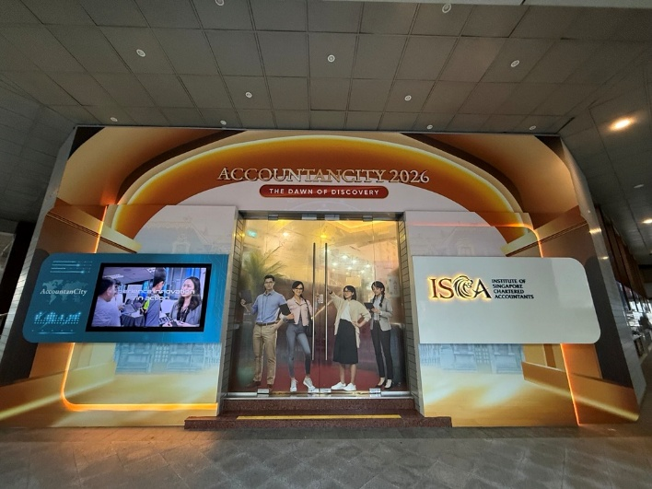 | 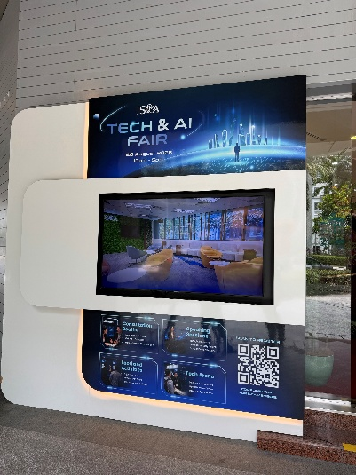
Entrance Deco @ L1
Tech Fair Deco (Right)
Top: 1940mm(L) x 780mm(H)
Bottom: 1940mm(L) x 740mm(H)

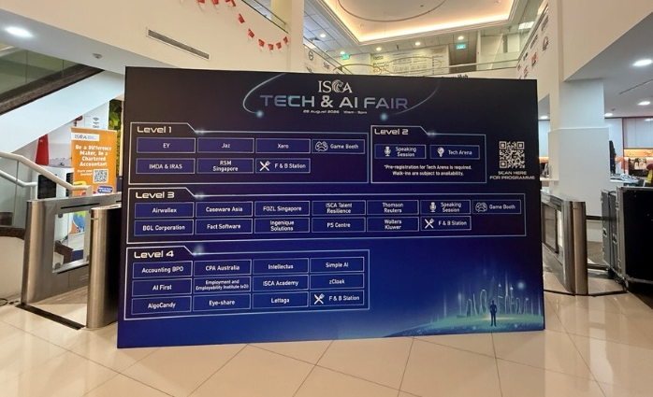 | 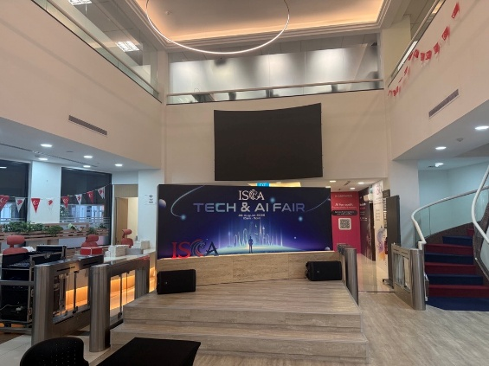
Directory Board @ L1 – 3m x 2.4mH

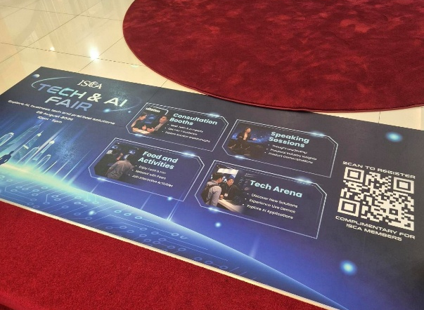
Floor Sticker @ L1 - 2300mm x 1000mm

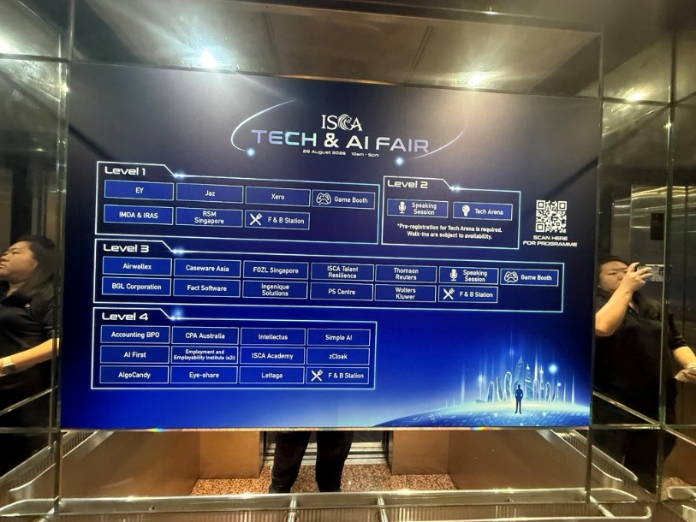
Lift Decal Sticker - 1300mm(W) x 850mm(H)

